Binary to Excess-3 Converter

Theory
Binary to Excess-3 converter is a combinational logic circuit that converts a 4-bit Binary Coded Decimal (BCD) input into its corresponding Excess-3 code. The Excess-3 code is obtained by adding 3 (0011) to the BCD input. It is a non-weighted code and is self-complementing, which makes it useful in digital systems.

Task
Design and implement a Binary to Excess-3 converter using logic gates and verify the results with a truth table.

Mathematical Rule
Excess-3 Output = Binary Input + 3 (0011)

Truth Table:
Binary Input |  |  |  | Access 3 Output
A | B | C | D | W | X | Y | Z
0 | 0 | 0 | 0 | 0 | 0 | 1 | 1
0 | 0 | 0 | 1 | 0 | 1 | 0 | 0
0 | 0 | 1 | 0 | 0 | 1 | 0 | 1
0 | 0 | 1 | 1 | 0 | 1 | 1 | 0
0 | 1 | 0 | 0 | 0 | 1 | 1 | 1
0 | 1 | 0 | 1 | 1 | 0 | 0 | 0
1 | 0 | 0 | 0 | 1 | 0 | 1 | 1
1 | 0 | 0 | 1 | 1 | 1 | 0 | 0

Working
The converter works by adding binary 0011 to the BCD input. For example, if the input is 0010 (decimal 2), adding 0011 results in 0101 (decimal 5 in Excess-3). The logic is implemented using combinational circuits derived from Karnaugh maps.

Diagram:

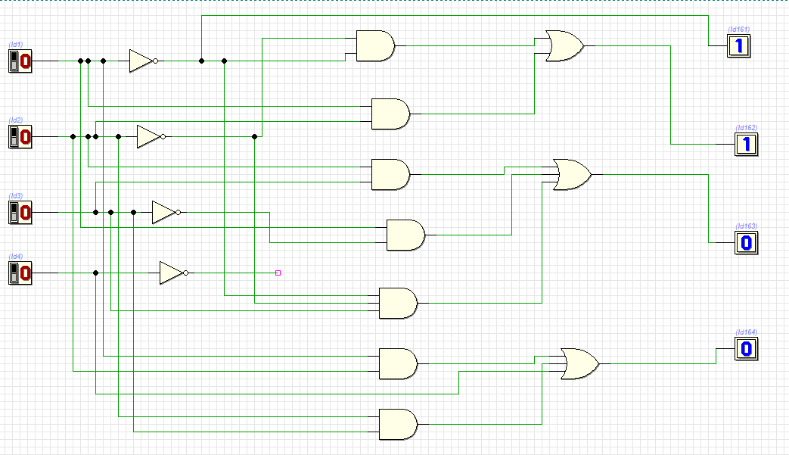

Procedure
- Write the truth table for BCD to Excess-3 conversion.
- Simplify the Boolean expressions using K-maps.
- Implement the circuit using logic gates (AND, OR, NOT).
- Connect the circuit on a breadboard using ICs.
- Apply inputs and verify outputs.

Hardware Components
IC 7408 (AND Gates) IC 7432 (OR Gates) IC 7404 (NOT Gates)
Breadboard, wires, power supply

Conclusion
The Binary to Excess-3 converter successfully converts BCD inputs into Excess-3 outputs. It is widely used due to its simplicity and self-complementing property.

Learning Outcomes
- Understand code conversion in digital systems
- Learn implementation using logic gates
- Gain knowledge of K-map simplification
- Understand practical circuit building

Task
Design and implement a Binary to Excess-3 converter using logic gates and verify the results with a truth table.

